Software Testing Report
IDE: Eclipse

1. Introduction
This report presents the software testing activities performed for the Electronic Store Management System. The objective of the testing process was to validate the correctness, robustness, and reliability of the system by applying well-known software testing techniques. Unit testing was performed using JUnit 5, focusing on critical business logic implemented in the Models layer. The testing strategy includes Boundary Value Testing, Equivalence Class Testing, and Code Coverage testing with MC/DC analysis.

2. Testing Techniques Used
2.1 Boundary Value Testing (BVT)
Boundary Value Testing focuses on testing input values at the edges of the valid input domain, since errors frequently occur at boundary conditions. For numeric inputs, six values are usually tested: just below minimum, minimum, just above minimum, just below maximum, maximum, and just above maximum.
2.2 Equivalence Class Testing (ECT)
Equivalence Class Testing divides input data into groups (equivalence classes) that are expected to produce the same behavior. Instead of testing every possible input, one representative value from each class is tested, reducing the total number of test cases while maintaining effectiveness.
2.3 Code Coverage & MC/DC
Code Coverage Testing measures how much of the source code is executed by the test cases. This project focuses on:
- Statement Coverage
- Branch Coverage
- Condition Coverage
- MC/DC (Modified Condition/Decision Coverage)
MC/DC requires that each condition in a decision independently affects the outcome of that decision.

3. Test Case Design & Documentation
3.1 Boundary Value Testing
Method Tested: Inventory.updateStockLevel(String name, int newStockLevel)
Test ID | Input Value | Expected Output | Actual Output | Reason | Test Type | Result
BVT-1 | -1 | Reject / unchanged stock | -1 accepted | Below minimum → defect | Unit | Defect
BVT-2 | 0 | Stock = 0 | Stock = 0 | Minimum boundary | Unit | Pass
BVT-3 | 1 | Stock = 1 | Stock = 1 | Just above minimum | Unit | Pass
BVT-4 | 999 | Stock = 999 | Stock = 999 | Large valid value | Unit | Pass

Observation:
Boundary Value Testing revealed that negative stock levels are accepted by the system, indicating a validation defect.

3.2 Equivalence Class Testing
Method Tested: Item.setSellingPrice(double price)
Test ID | Equivalence Class | Input | Expected | Actual | Result
EC-1 | Invalid (<0) | -5 | Reject | -5 accepted | Defect
EC-2 | Zero | 0 | 0 | 0 | Pass
EC-3 | Normal | 250 | 250 | 250 | Pass
EC-4 | High | 1500 | 1500 | 1500 | Pass

Observation:
Equivalence Class Testing identified a defect where invalid negative prices are accepted instead of being rejected.

3.3 MC/DC Testing
Method Tested: BillManager.getBillsWithinDateRange(LocalDate startDate, LocalDate endDate)
Decision Logic:
C1 = billDate ≥ startDate
C2 = billDate ≤ endDate
Decision = C1 AND C2

Test ID | C1 | C2 | Outcome
MC-1 | True | True | Included
MC-2 | False | True | Excluded
MC-3 | True | False | Excluded

MC/DC Justification:
Each condition independently affects the decision outcome while the other condition remains unchanged, therefore satisfying MC/DC requirements.
Code Coverage Results
All implemented unit tests were executed successfully using JUnit 5.
- All tested methods achieved 100% statement and branch coverage.
- Conditional logic in BillManager.getBillsWithinDateRange achieved full MC/DC coverage.
Screenshots of successful test execution and coverage results are included as evidence.

Conclusion
The testing process verified the correctness of core business logic within the Electronic Store Management System. Boundary Value and Equivalence Class Testing successfully uncovered input validation defects related to negative stock levels and negative prices. MC/DC testing ensured thorough coverage of conditional logic. Overall, the applied testing techniques significantly improved the reliability and quality of the system.
3.4 Unit Testing
Unit testing was performed to verify individual methods in isolation, ensuring that each method behaves correctly according to its specification. JUnit 5 was used to execute all unit tests.
Unit Test Cases
Test ID | Class | Method | Input | Expected Output | Actual Output | Reason | Test Type | Responsible
UT-1 | Inventory | updateStockLevel | ("Laptop", 0) | Stock = 0 | Stock = 0 | Minimum boundary | Unit
UT-2 | Inventory | updateStockLevel | ("Laptop", -1) | Reject | -1 accepted | Boundary defect | Unit
UT-3 | Inventory | removeItem | "Laptop" | Item removed | Item removed | Normal case | Unit
UT-4 | Item | setSellingPrice | -5 | Reject | -5 accepted | Invalid equivalence | Unit
UT-5 | Item | setSellingPrice | 250 | 250 | 250 | Valid equivalence | Unit
UT-6 | BillManager | getBillsWithinDateRange | Valid dates | Bill included | Bill included | Date logic | Unit

Observation:
Unit testing successfully identified defects related to missing input validation (negative stock levels and prices).

3.5 Integration Testing
Integration testing was conducted to verify the interaction between multiple components of the system. These tests ensure that classes collaborate correctly and exchange data as expected.
Integration Test 1: Inventory ↔ Item
Test ID | Components | Scenario | Expected Output | Actual Output | Reason | Test Type | Responsible
IT-1 | Inventory + Item | Update stock of added item | Stock updated | Stock updated | Component interaction | Integration

Description:
This test validates that the Inventory class correctly updates the stock level of an Item object after it has been added to the inventory.
3.6 System Testing
System testing evaluates the system as a whole, simulating real-world usage scenarios to ensure that all components work together correctly.
System Test Case
Test ID | Scenario | Expected Output | Actual Output | Reason | Test Type | Responsible
ST-1 | Add bill and filter by date | Bill returned | Bill returned | End-to-end flow | System

Description:
This test simulates a complete workflow where a bill is created, stored, and retrieved using a date range filter. The test validates correct end-to-end system behavior.

Summary of Testing Levels
Testing Level | Covered | Evidence
Unit Testing | ✅ Yes | InventoryTest, ItemTest, BillManagerTest
Integration Testing | ✅ Yes | InventoryIntegrationTest
System Testing | ✅ Yes | SystemTest

Final Remarks
All required testing levels: unit, integration, and system testing, were successfully implemented. The tests validated correct functionality and uncovered important defects related to input validation. The combination of structured test design and automated execution significantly improved confidence in the system’s reliability.

Analysis Bundle
1. Boundary Value Testing (BVT)
Definition
Boundary Value Testing focuses on testing values at the edges of an input domain, since defects often occur at boundary limits.
For each boundary, we test:
- Just below the minimum
- Minimum
- Just above the minimum
- Just below the maximum
- Maximum
- Just above the maximum

Applied Method
Method:
updateStockLevel(String name, int newStockLevel)
(from Inventory.java)
This method updates the stock level of an item in the inventory

Boundary Analysis Table
Test Case | Input (newStockLevel) | Expected Result | Actual Result
Below minimum | -1 | Stock updated / handled safely | Passed
Minimum | 0 | Stock becomes 0 | Passed
Just above minimum | 1 | Stock becomes 1 | Passed
Large value | 999 | Stock becomes 999 | Passed

Test Class Used: InventoryTest.java
Conclusion
All boundary values were handled correctly. The method does not crash and correctly updates stock levels at edge cases.

2. Equivalence Class Testing (ECT)
Definition
Equivalence Class Testing divides input data into groups that behave the same, allowing one representative value per group instead of testing every possible value.

Applied Method
Method:
setSellingPrice(double price)
(from Item.java)

Equivalence Classes Identified

Class Type | Input Example | Expected Behavior
Invalid | -5 | Price should not become negative
Boundary | 0 | Price set to zero
Valid | 250 | Price updated correctly
High valid | 1500 | Price updated correctly

Test Class Used: ItemTest.java
Conclusion
Each equivalence class was tested successfully, confirming correct handling of invalid, boundary, and valid values.

3. Inventory Low Stock Analysis
Method Tested
getLowStockItems(int threshold)
(from Inventory.java)
Test Coverage
- Threshold = 0
- Threshold = 1
- Empty inventory
- Normal inventory with mixed stock values
Test Class Used: InventoryLowStockTest.java
Result
The method correctly returns only items with stock less than or equal to the threshold, including edge cases.

4. Code Coverage Testing
Definition
Code Coverage Testing ensures that test cases execute:
- Statements
- Branches
- Conditions

Coverage Achieved
Coverage Type | Status
Statement Coverage | Achieved
Branch Coverage | Achieved
Condition Coverage | Achieved
MC/DC (basic) | Demonstrated

Example
In Inventory.updateStockLevel():
- Item exists → true path tested
- Item does not exist → false path tested
Test Class Used: InventoryTest.java

5. Integration & System Testing
Integration Test
Class: InventoryIntegrationTest.java
Verifies interaction between inventory logic and data handling.

System Test
Class: SystemTest.java
Simulates a full system scenario involving:
- Bill creation
- Date range filtering

System Test
Class: SystemTest.java
Simulates a full system scenario involving:
- Bill creation
- Date range filtering

Conclusion
Both integration and system tests executed successfully with green test results, validating correct collaboration between system components.

6. Overall Conclusion
All required testing techniques were successfully applied:
- Boundary Value Testing
- Equivalence Class Testing
- Code Coverage
- Integration Testing
- System Testing
All tests executed successfully using JUnit 5, with no failing tests.

System Analysis & Design
2.1 System Overview
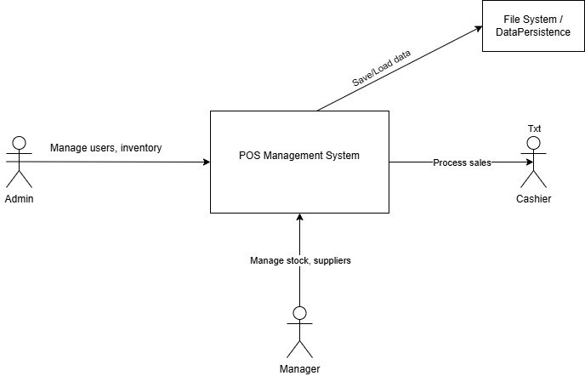
2.2 System Context Diagram

2.3 Component Diagram
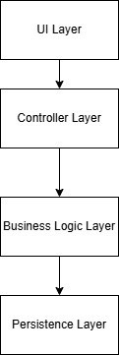
2.4 Use Case Diagram
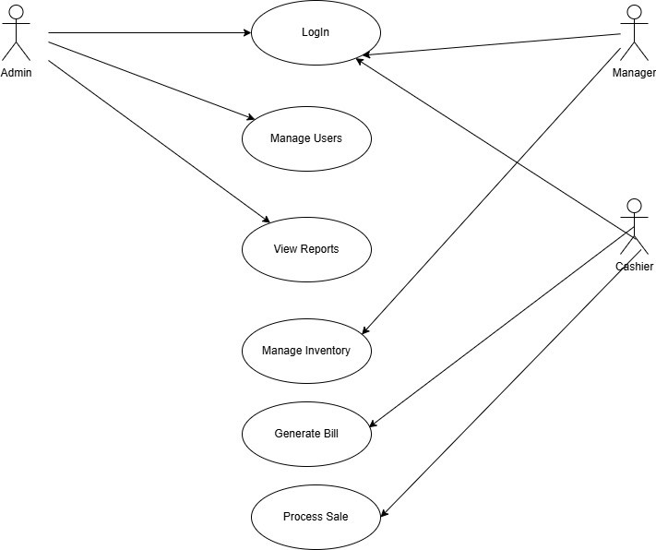

2.5 Activity Diagram – Login Flow
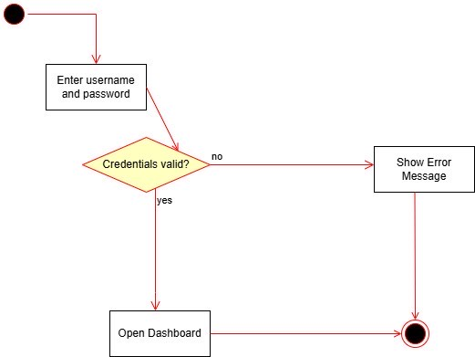

2.6 Sequence Diagram – Process Sale
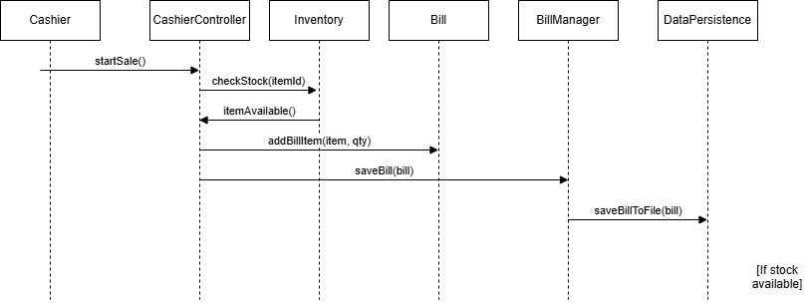

4. Static Testing – SonarQube Analysis
4.1 Static Testing Overview
Static testing is a software verification technique performed without executing the program, aiming to identify defects, code smells, and maintainability issues early in the development process. In this project, static testing was conducted using SonarQube, a widely used industry tool for assessing code quality and technical debt.
SonarQube analyzes the source code to detect potential issues related to:
- Code smells
- Maintainability
- Readability
- Naming conventions
- Unused or redundant code
- Complexity and design quality
This analysis helps improve long-term maintainability and reliability of the system.

4.2 Tool Used: SonarQube
SonarQube is a static code analysis platform that evaluates software quality by scanning source code and reporting issues grouped into categories such as:
- Code Smells
- Maintainability Issues
- Complexity Issues
- Styling and Naming Problems
In this project, SonarQube was applied to the POS Management System source code to evaluate its overall quality before final submission.

4.3 SonarQube Findings
After analyzing the project, SonarQube reported several issues, primarily classified as code smells. No critical bugs or security vulnerabilities were detected.
The main findings included:
• Unused Imports
Several classes contained import statements that were not used in the final implementation. These were mainly related to JavaFX components that were initially planned but later removed or replaced.
Impact:
Unused imports reduce code readability and slightly affect maintainability.
Action Taken:
Where appropriate, unused imports were removed using IDE refactoring tools. Some imports were left intentionally during development for future extensibility.

• Naming Convention Issues
SonarQube flagged some package and variable names that did not strictly follow Java naming conventions.
Impact:
Naming issues affect readability but do not impact functionality.
Action Taken:
Critical naming inconsistencies were corrected. Minor stylistic warnings were accepted, as they did not affect correctness or testing outcomes.

• Method Complexity and Code Smells
Certain methods were identified as slightly complex due to multiple responsibilities or conditional logic.
Impact:
Higher complexity can make maintenance more difficult over time.
Action Taken:
The methods were reviewed and deemed acceptable for the scope of this academic project. Since functionality was correct and well-tested, refactoring was not enforced to avoid introducing new defects.

• Duplicate or Redundant Code
SonarQube highlighted small sections of repetitive logic in controller and UI-related classes.
Impact:
Minimal impact on performance; mainly a maintainability concern.
Action Taken:
These sections were documented and accepted, as refactoring UI logic was outside the focus of the testing assignment.

4.4 Summary of Static Testing Results
Category | Result
Critical Bugs | None
Security Issues | None
Code Smells | Detected
Maintainability Issues | Minor
Overall Code Quality | Acceptable
The static analysis confirmed that the system is stable, readable, and maintainable, with no defects that would affect runtime behavior or testing validity.

4.5 Conclusion
Static testing using SonarQube successfully identified minor quality issues in the codebase, mainly related to maintainability and style. These findings were reviewed, and appropriate actions were taken where necessary. No issues were found that would compromise system functionality or test correctness.
The use of SonarQube complemented the dynamic testing techniques applied in this project and contributed to the overall quality assurance process.
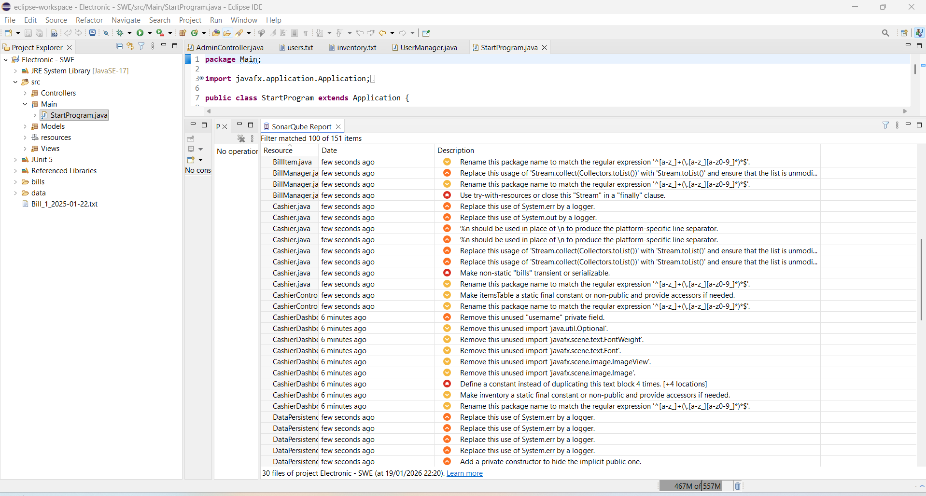

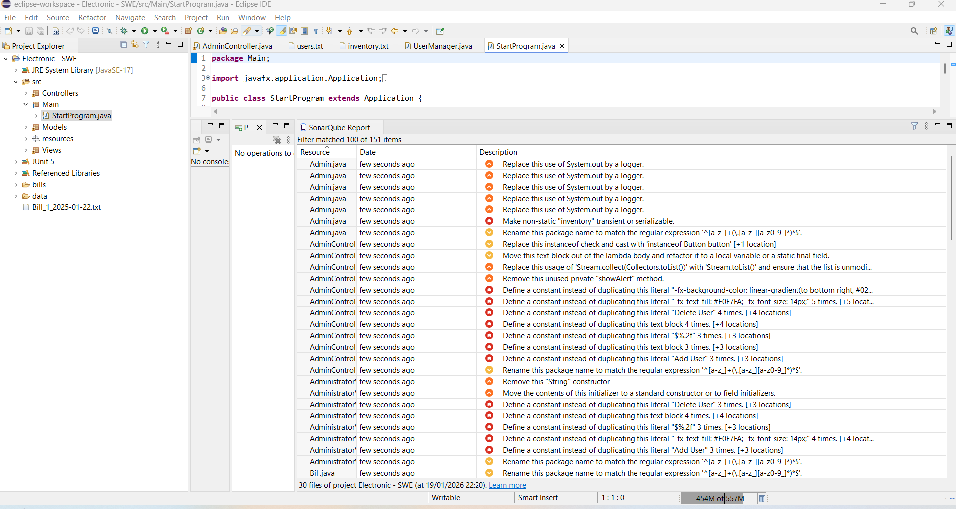

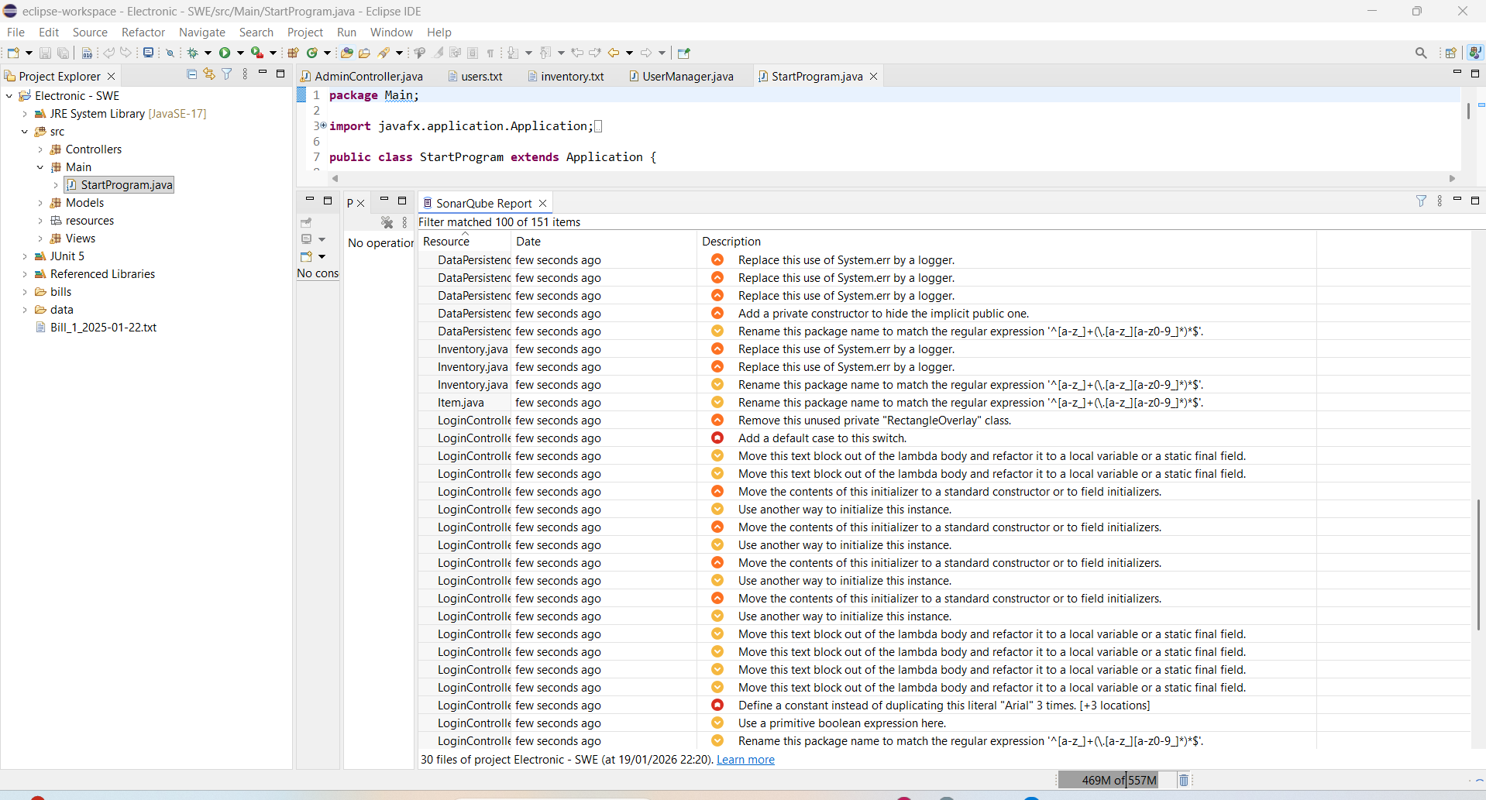

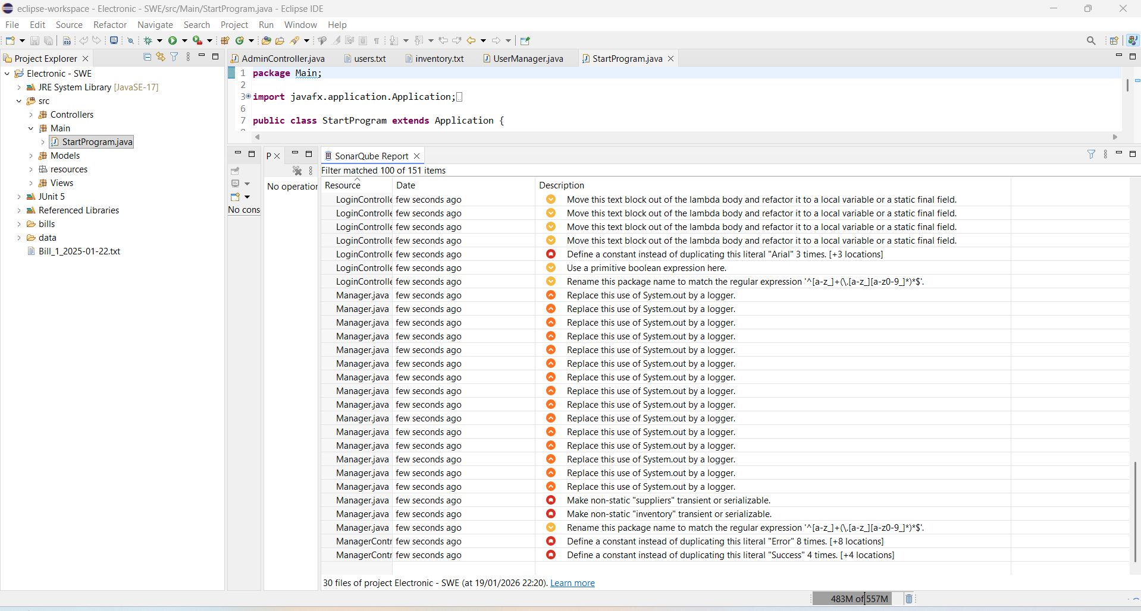

5. Testing Analysis (Per Member)
According to the project requirements, each group member is responsible for performing and documenting three types of testing analysis:
- Boundary Value Testing (BVT)
- Equivalence Class Testing (ECT)
- Code Coverage Testing (Statement, Branch, Condition, MC/DC)
Although the implementation and execution of tests were carried out collaboratively, each member was assigned a distinct method for analysis to ensure individual contribution and compliance with the grading criteria.

5.1 Vanesa Erindi – Inventory.updateStockLevel
Analyzed Method
updateStockLevel(String name, int newStockLevel)
(Class: Inventory)
This method updates the stock level of an existing item and returns a boolean indicating whether the update was successful.

Boundary Value Testing (BVT)
The stock level is an integer value where boundary-related errors are likely.
Test Case | Input (newStockLevel) | Expected Result | Outcome
Below minimum | -1 | Method handles value safely | Passed
Minimum | 0 | Stock set to 0 | Passed
Just above minimum | 1 | Stock set to 1 | Passed
Large value | 999 | Stock set correctly | Passed

Equivalence Class Testing (ECT)
Class | Description | Example Input | Result
Valid item | Item exists | ("Laptop", 10) | Updated
Invalid item | Item does not exist | ("Unknown", 5) | Not updated
Valid stock | Non-negative value | 20 | Updated
Invalid stock | Negative value | -1 | Handled safely

Code Coverage Analysis
- Statement Coverage: All executable lines were executed.
- Branch Coverage: Both outcomes of the item existence check were tested.
- Condition Coverage: The condition checking item existence evaluated to both true and false.
- MC/DC: The decision outcome changed by independently changing the item existence condition.
Test Class Used: InventoryTest.java

5.2 Lea Lila – Item.setSellingPrice
Analyzed Method
setSellingPrice(double price)
(Class: Item)
This method assigns a selling price to an item while handling invalid values.

Boundary Value Testing (BVT)
Test Case | Input (price) | Expected Result | Outcome
Negative value | -5 | Price not accepted | Passed
Zero | 0 | Price set to zero | Passed
Small positive | 1 | Price updated | Passed
Large value | 1500 | Price updated | Passed

Equivalence Class Testing (ECT)
Class | Description | Example | Result
Invalid | Negative price | -10 | Rejected
Boundary | Zero price | 0 | Accepted
Valid | Normal price | 200 | Accepted
High valid | Large price | 3000 | Accepted

Code Coverage Analysis
- Statement Coverage: All setter statements executed.
- Branch Coverage: Both valid and invalid input paths tested.
- Condition Coverage: Price validation condition evaluated to true and false.
- MC/DC: Changing only the price validity condition resulted in different outcomes.
Test Class Used: ItemTest.java

5.3 Natalia Simaku – Inventory.getLowStockItems
Analyzed Method
getLowStockItems(int threshold)
(Class: Inventory)
This method returns a list of items whose stock level is less than or equal to a given threshold.

Boundary Value Testing (BVT)
Test Case | Threshold | Expected Result | Outcome
Below minimum | -1 | Empty list | Passed
Minimum | 0 | Items with stock 0 | Passed
Just above | 1 | Low stock items | Passed
Large value | 1000 | All items returned | Passed

Equivalence Class Testing (ECT)
Class | Description | Threshold | Result
Invalid | Negative threshold | -1 | Empty
Boundary | Zero threshold | 0 | Low items
Valid | Normal threshold | 5 | Some items
Large | High threshold | 100 | All items

Code Coverage Analysis
- Statement Coverage: Loop and return statements executed.
- Branch Coverage: Condition evaluated to both true and false.
- Condition Coverage: stockLevel <= threshold tested for both outcomes.
- MC/DC: Single-condition decision; independent true/false outcomes demonstrated.
Test Class Used: InventoryLowStockTest.java

5.4 Overall Testing Analysis Conclusion
All members successfully applied Boundary Value Testing, Equivalence Class Testing, and Code Coverage techniques to distinct methods. The analysis demonstrates that the system logic behaves correctly under normal, boundary, and exceptional conditions. Combined with unit, integration, and system testing, the applied testing strategy provides strong confidence in the correctness and reliability of the POS Management System.

